Flash Tutorial
Note: This tutorial can be used for miners of different types. Here we take CK5 for example.
PART1
After you receive the “rufus software” (e.g. rufus-3.20(1) Shown as Fig.1) and the firmware (e.g. Please unzip this file-CK5-2.1.4 Shown as Fig.2)
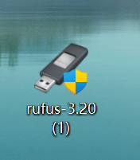
Fig.1
We recommend to use WinRAR software to unzip this file.
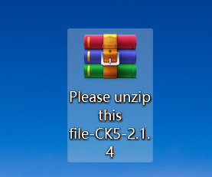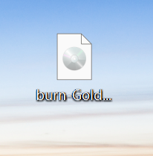
UNZIP
Fig.2

- Install Rufus and open it. (Shown as Fig.3)
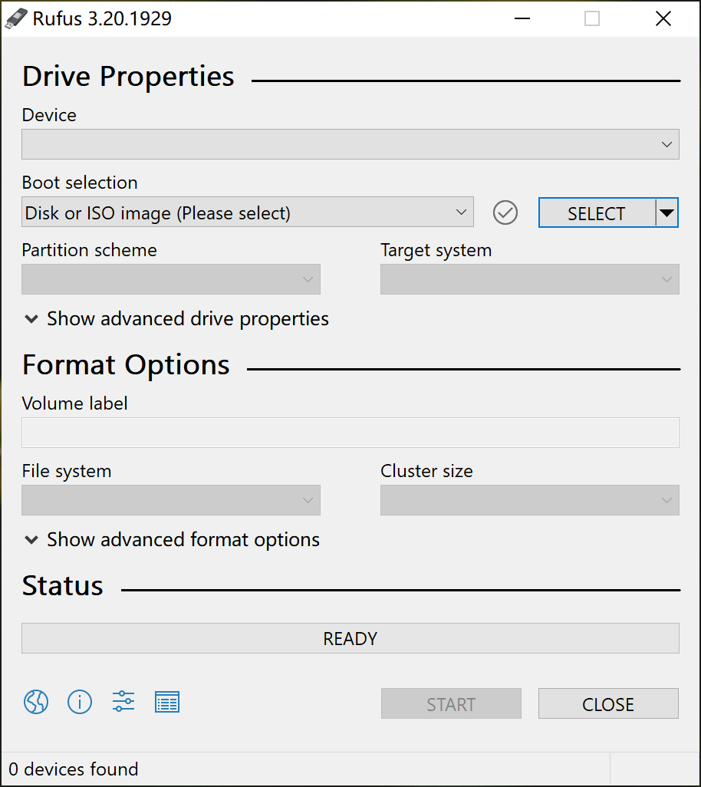
Fig.3
- Prepare a card reader and SD card exceeding 4GB (Fig.4), and then format the card. (Note: remember to save and transfer the current files in the SD card first.)
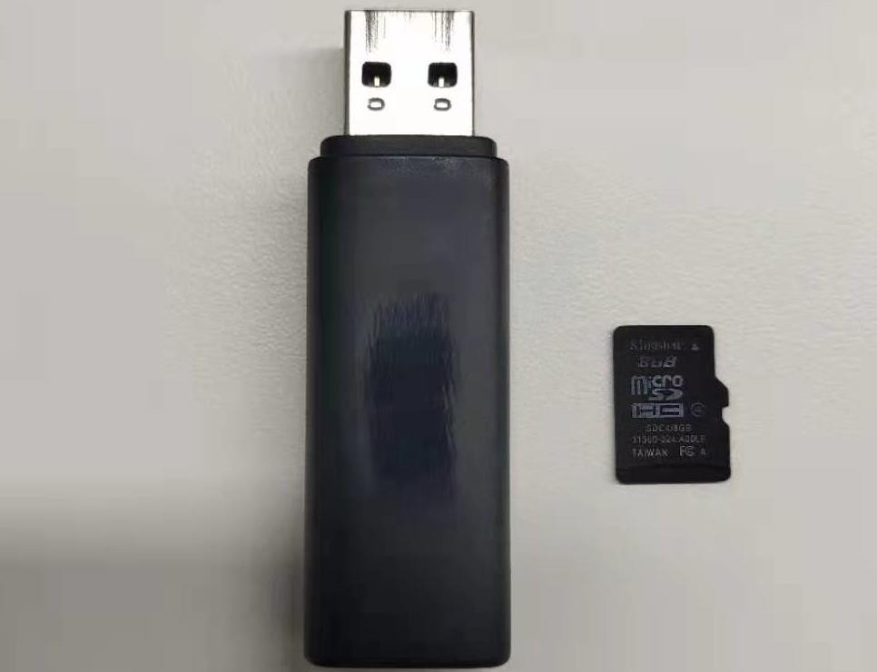

Fig.4
- Insert the SD card into the computer USB port. Make sure there are no other storage devices such as U disk, other SD card in the computer. The software will read the relative information once the SD card connects successfully. (Fig.5)
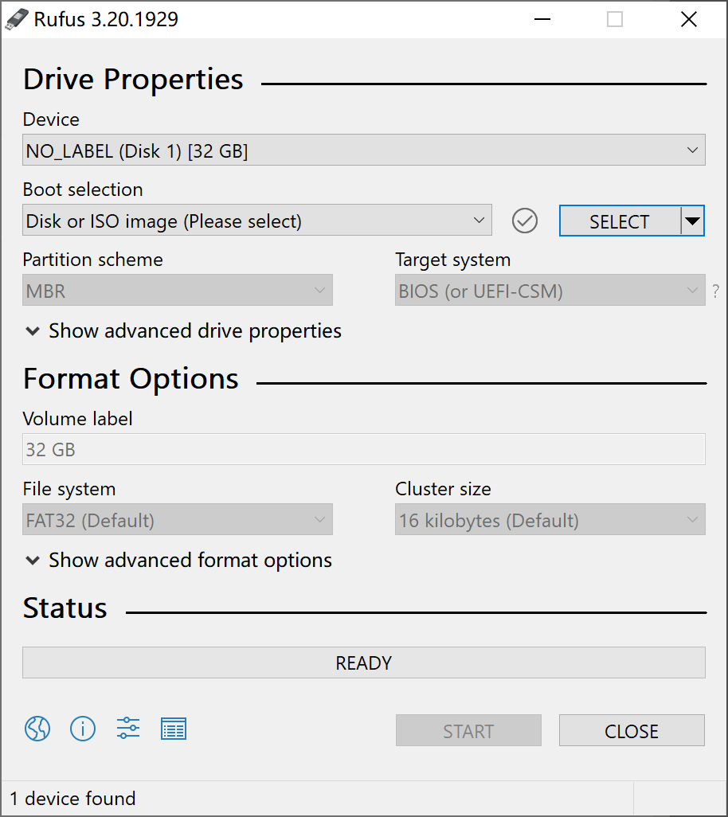
Fig.5
- Go to the Boot Selection column, select “Disk or ISO image (please select)”. In the same row, click “SELECT” button to upload the burn firmware. After you select the corresponding burn firmware, go to the bottom and click “START”. In the meantime, a dialogue box will pop up, just click “confirm”. Refer to Fig. 6&7.
Fig.6
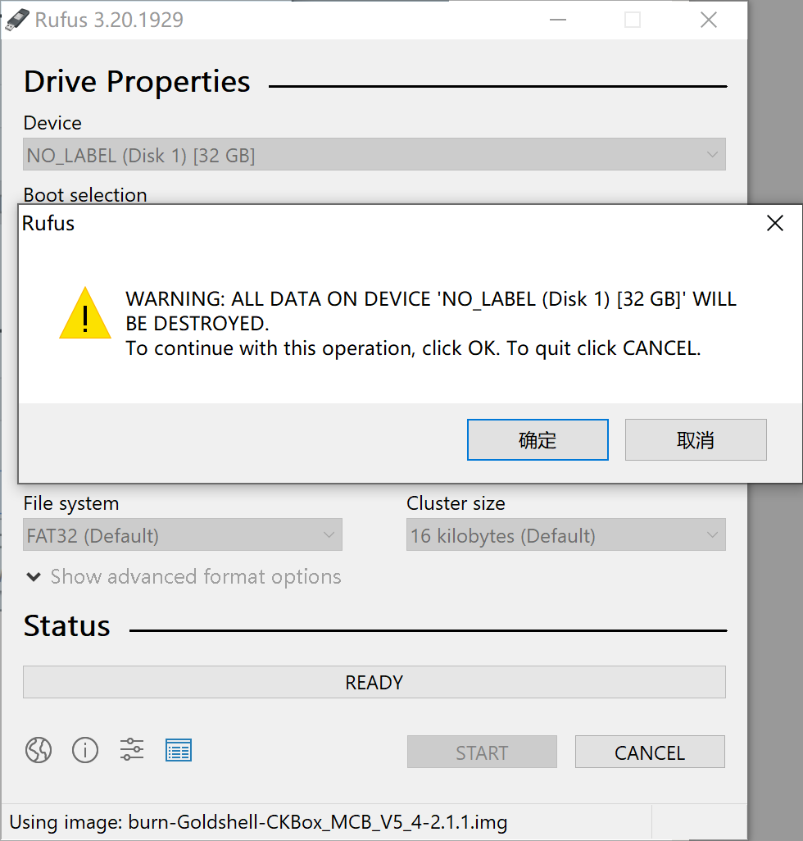
Fig.7

- When the bottom bar turns green, it means the process is beginning; when it shows “READY”, means the process is finished, you can click “CLOSE” and pull out the SD card.
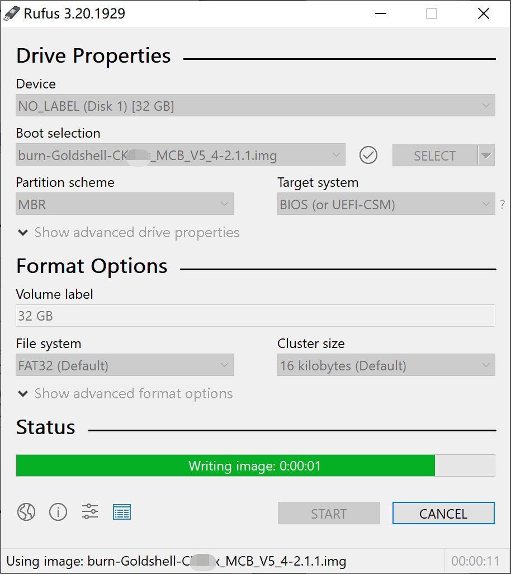
Fig. 8
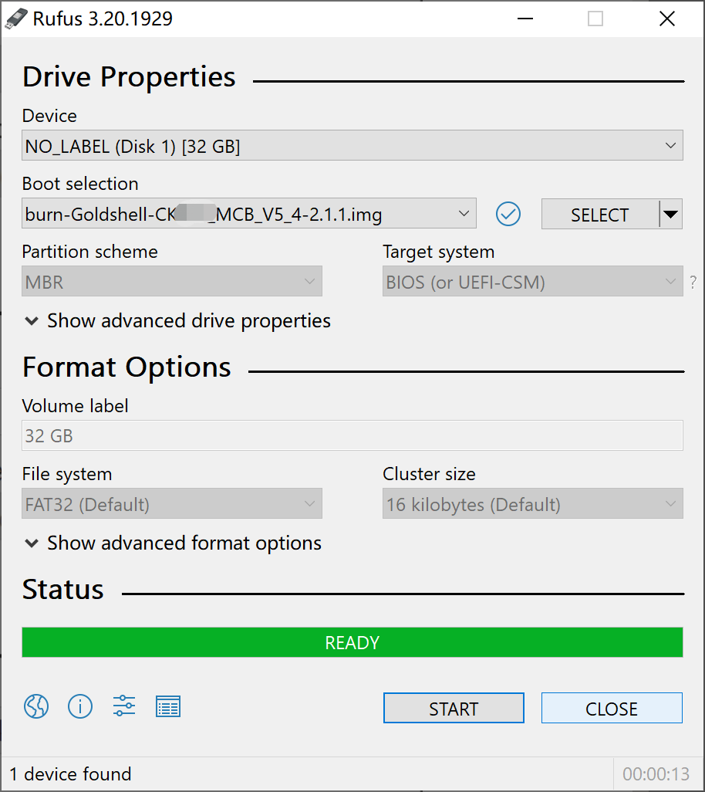
Fig. 8

PART 2
Insert the SD card into the miner
- Power off Miner, then insert the SD card into the slot alongside the indicator light. (Fig.9)

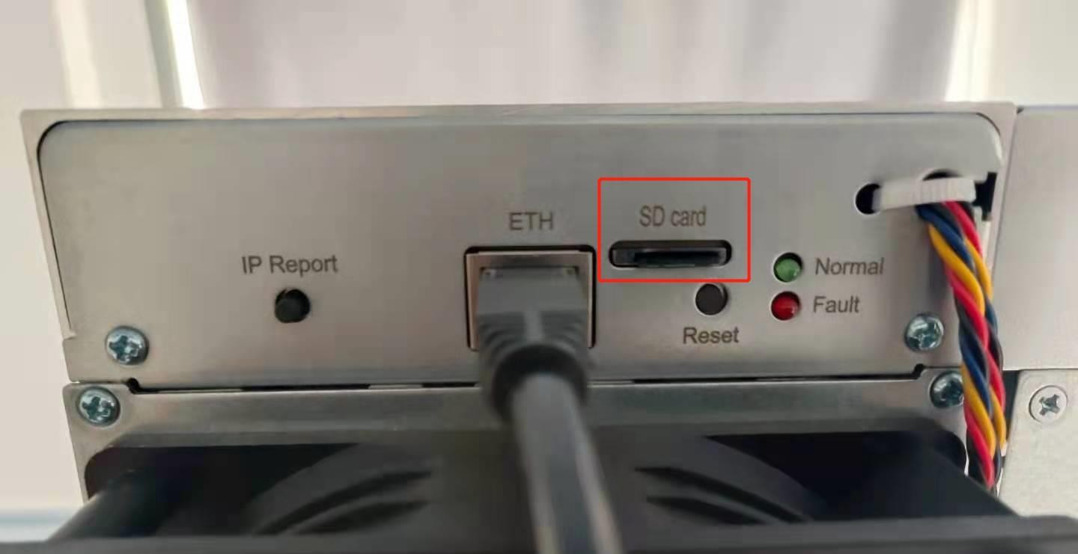
Fig.9

- Power on the Miner, then you can see the red and green/blue lights flash together, which will last about 90 seconds. Wait for a while if there are no lights at the beginning, if they still aren't on, please contact us.
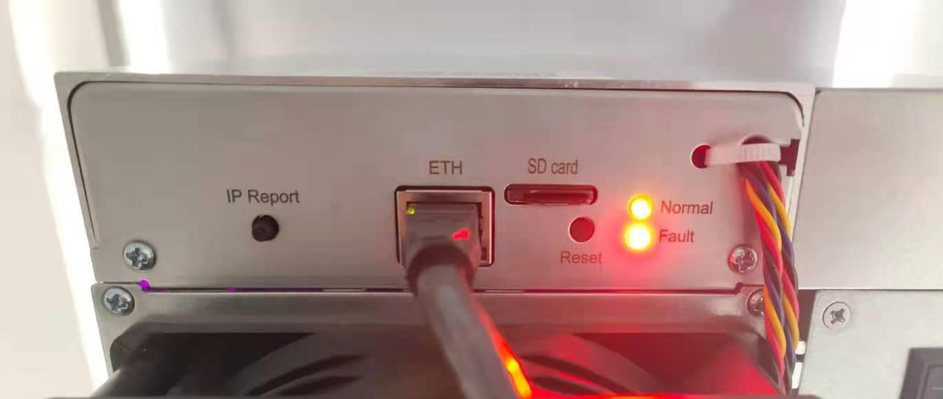
Fig.10

- Wait until only the green/blue light flashes, which means the burning process is basically completed. Then pull out the SD card and insert the netcable, the miner will reboot automatically. When the green/blue light is flashing again, it means the miner is working. Note: make sure the power is on during the process. Otherwise, you need to redo all the procedures.
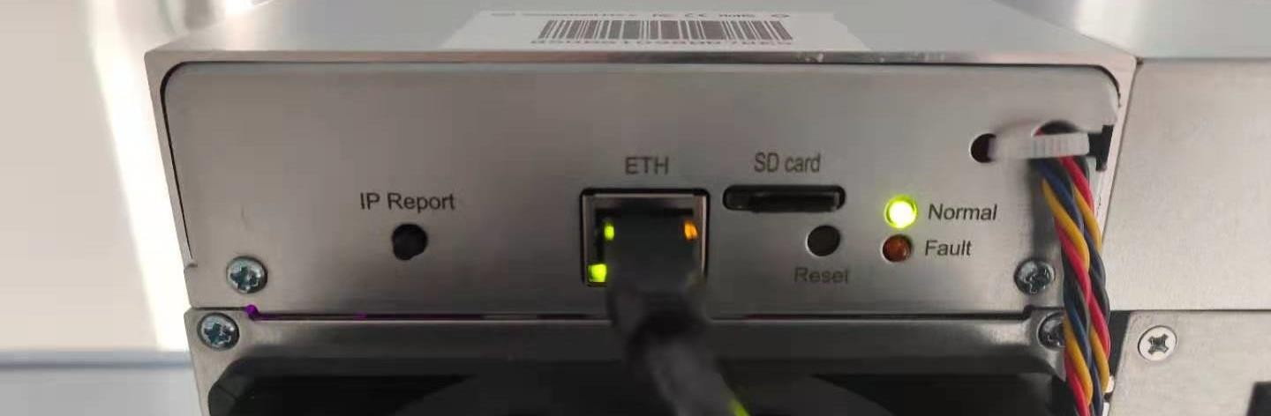
Fig.11

