Flash Tutorial
Note: This tutorial can be used for miners of different types. Here we take CK5 for example.
PART1
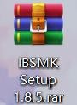
After you receive the compressed packages (e.g. IBSMK Setup 1.8.5 rar. Shown as Fig.1) and the firmware (e.g. Please unzip this file-CK5-2.1.4Shown as Fig.2)
UNZIP
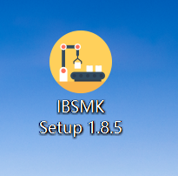
We recommend to use WinRAR software to unzip these files.
Fig.1
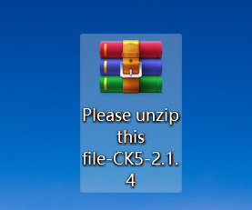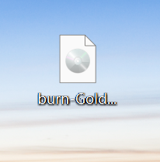
UNZIP
Fig.2

- Decompress and install the IBSMK Setup 1.8.5. and open it. (Shown as Fig.3)
Note: You’d better store the IBSMK on desktop.
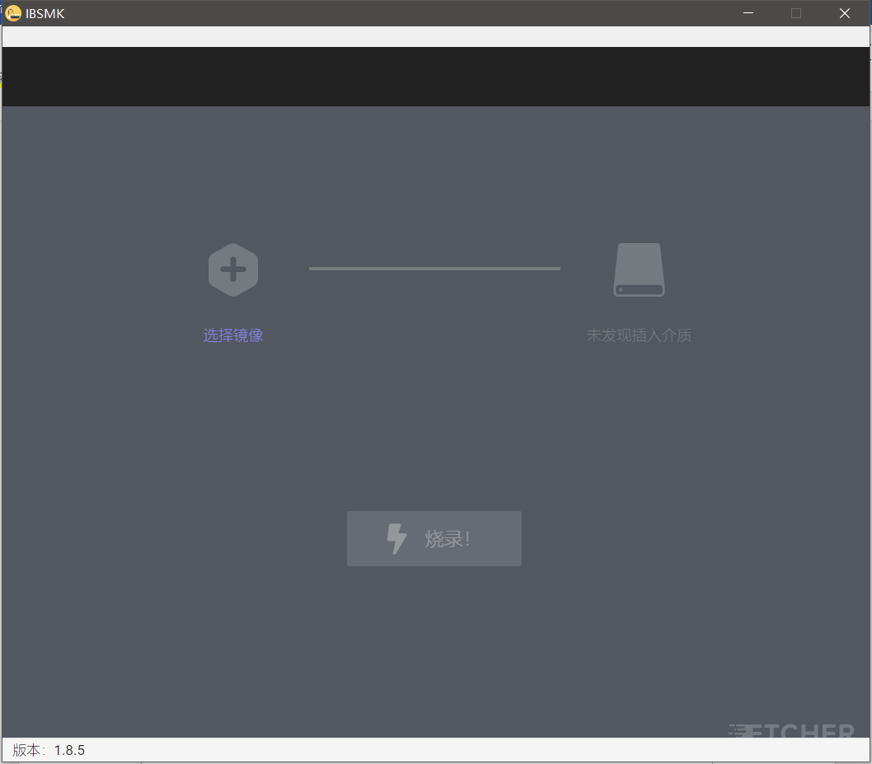
Fig.3

- Prepare a card reader and SD card exceeding 4GB (Fig.4), and then format the card. (Note: remember to save and transfer the current files in the SD card first.)

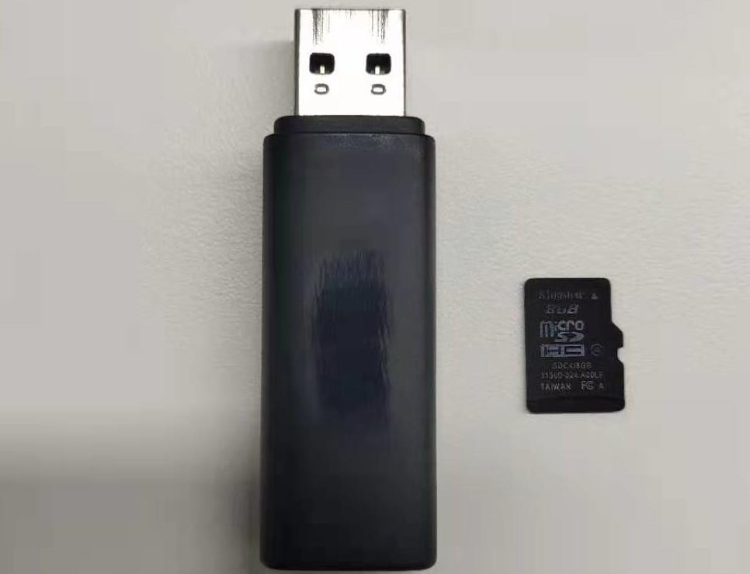

Fig.4
- Insert the SD card into the computer USB port. Make sure there are no other storage devices such as U disk, other SD card in the computer. The software will read the relative information once the SD card connects successfully. (Fig.5)
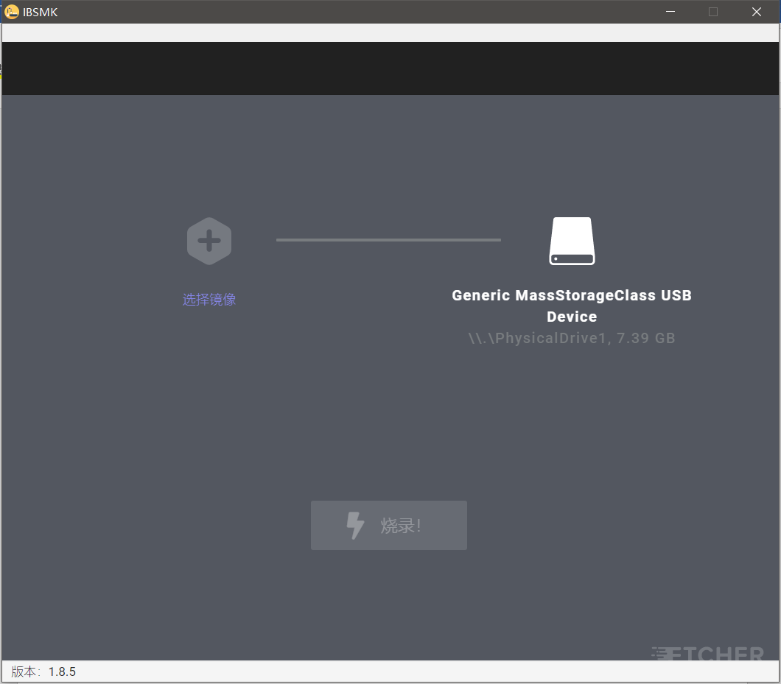
Fig.5
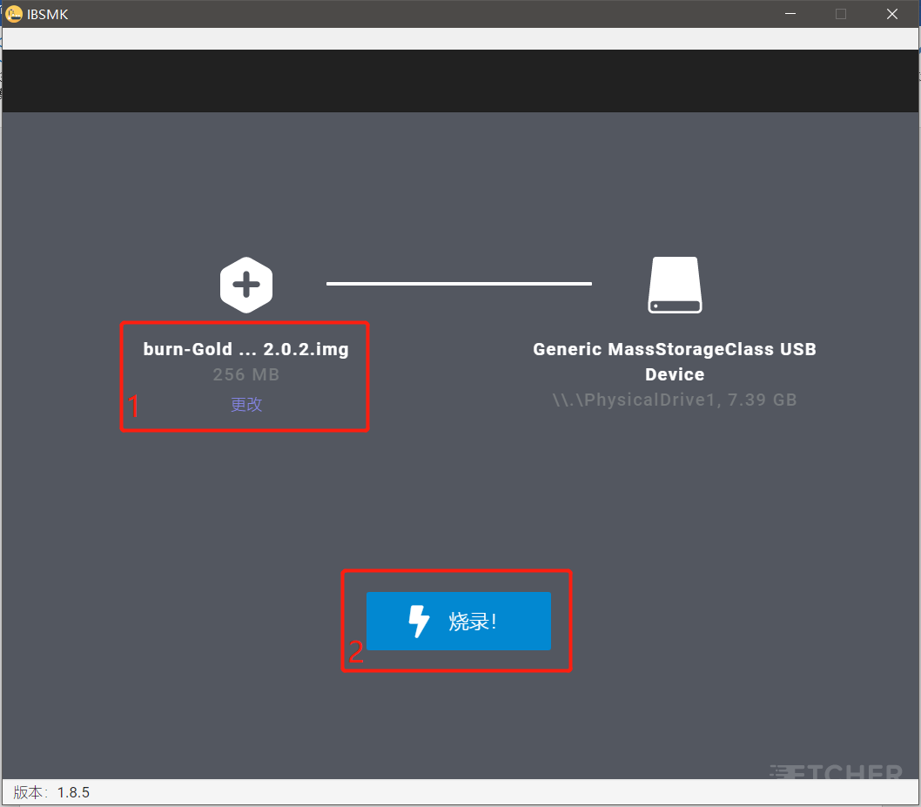
- Click “选择镜像” and upload the firmware, then START. (Shown as Fig.6 and Fig.7) Don’t close the software or pull out the SD card during the burning process. When it reaches 100, the process is completed. And then close the firmware and pull out the SD card.
Fig.6
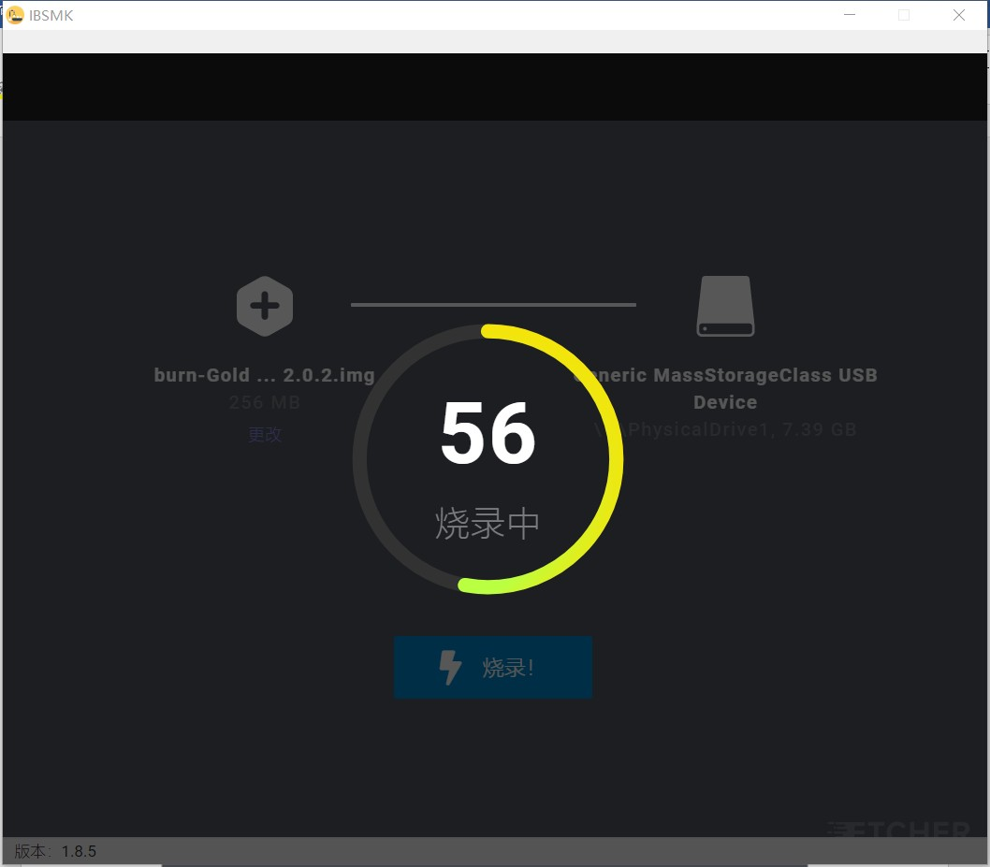
Fig.7

PART 2
Insert the SD card into the miner
- Power off Miner, then insert the SD card into the slot alongside the indicator light. (Fig.8)

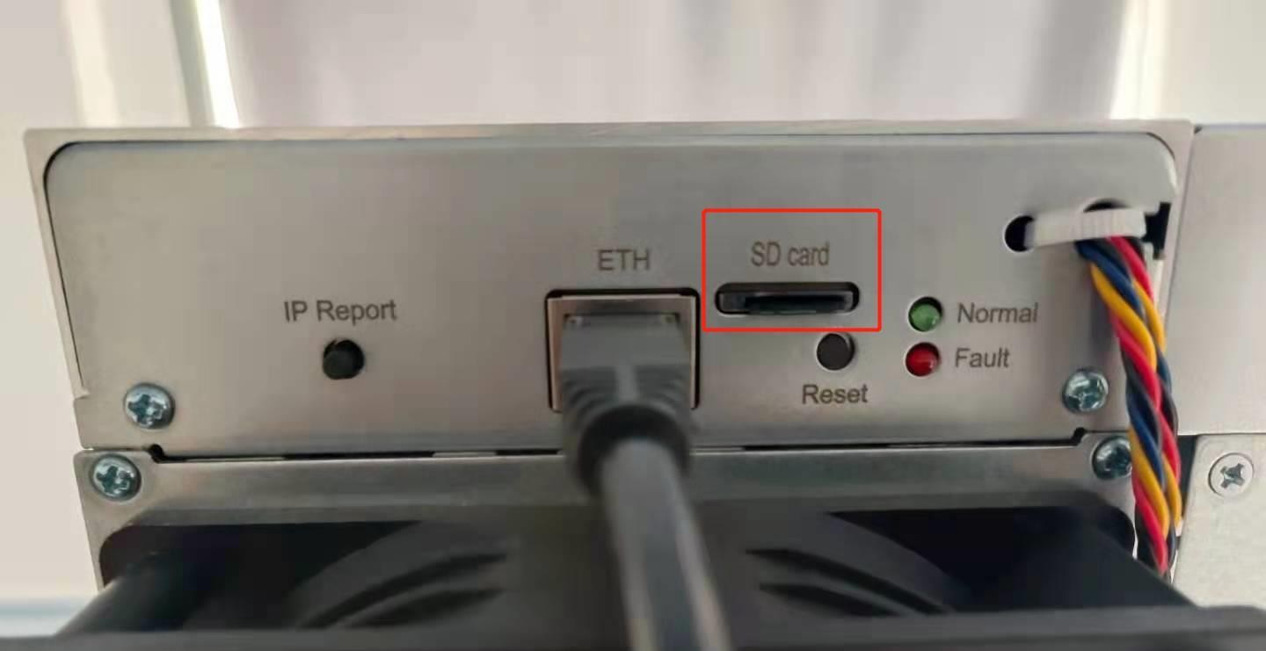
Fig.8

- Power on the Miner, then you can see the red and green/blue lights flash together, which will last about 90 seconds. Wait for a while if there are no lights at the beginning, if they still aren't on, please contact us.
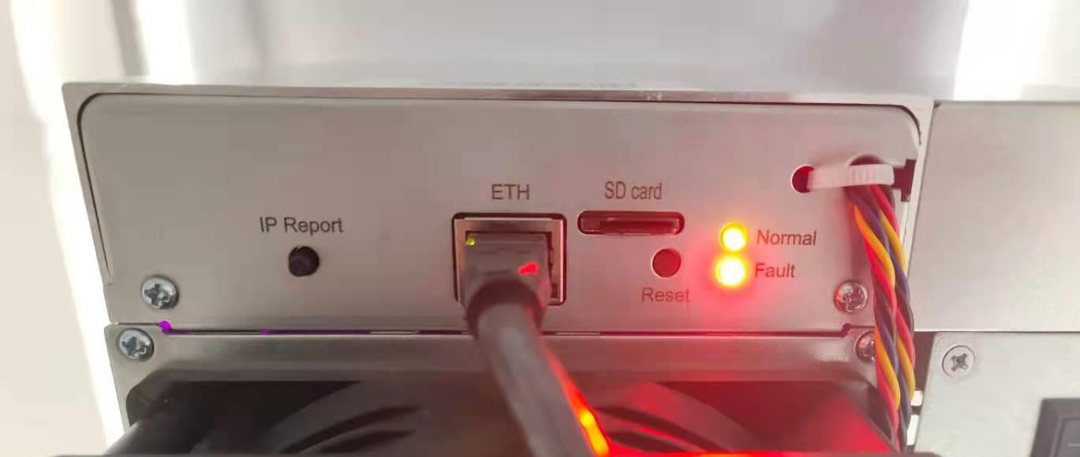
Fig.9

- Wait until only the green/blue light flashes, which means the burning process is basically completed. Then pull out the SD card and insert the netcable, the miner will reboot automatically. When the green/blue light is flashing again, it means the miner is working. Note: make sure the power is on during the process. Otherwise, you need to redo all the procedures.
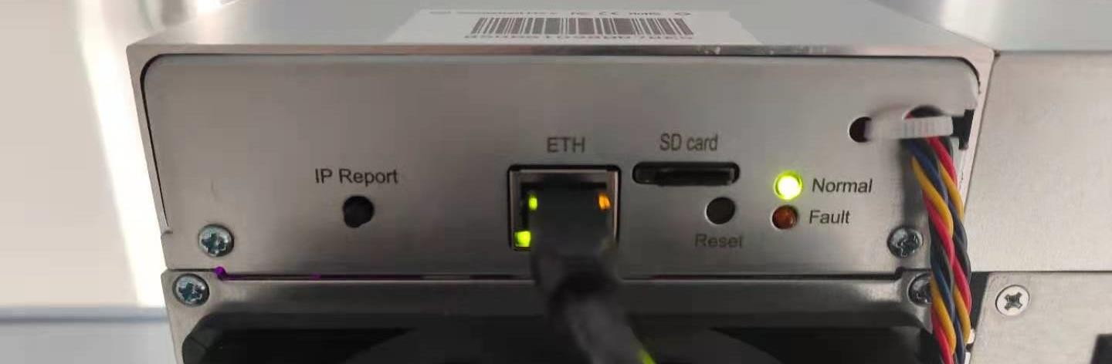
Fig.10

