Flash Tutorial
Note: This tutorial can be used for miners of different types. Here we take CK5 for example.
PART1
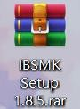
After you receive the compressed packages (e.g. IBSMK Setup 1.8.5 rar. Shown as Fig.1) and the firmware (e.g. Please unzip this file-CK5-2.1.4Shown as Fig.2)
UNZIP
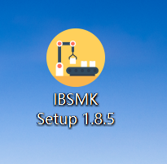
Fig.1
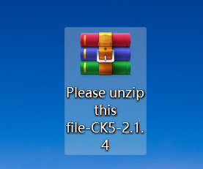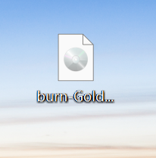
UNZIP
Fig.2

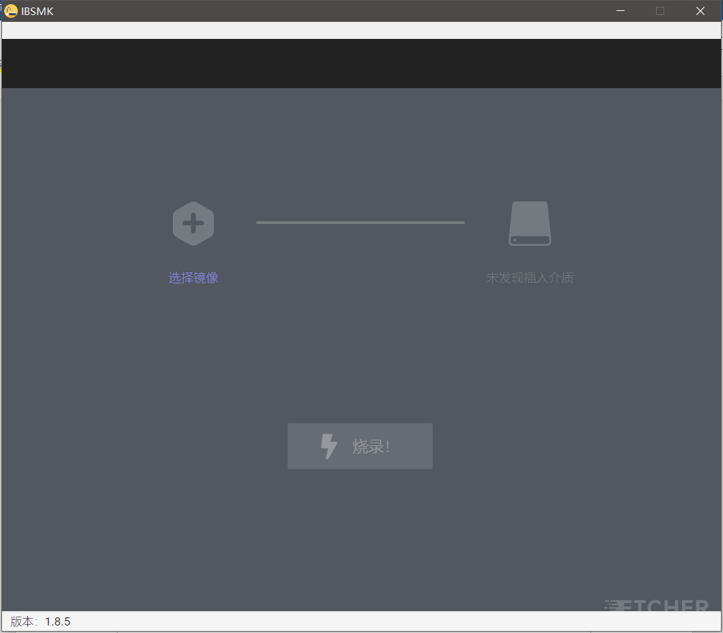
- Decompress and install the IBSMK Setup 1.8.5. and open it. (Shown as Fig.3)
Fig.3

- Prepare a card reader and SD card with exceed 4GB (Fig.4), and then format the card. (Note: remember to save and transfer the current files in the SD card.)

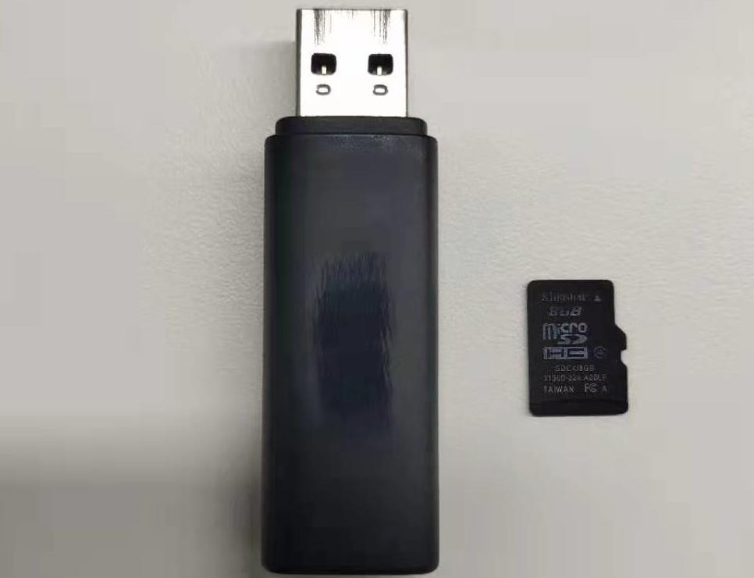

Fig.4
- Insert the SD card into the computer USB port. Make sure there are no other storage devices such as U disk, other SD card in the computer. The software will read the relative information once the SD card connects successfully. (Fig.5)
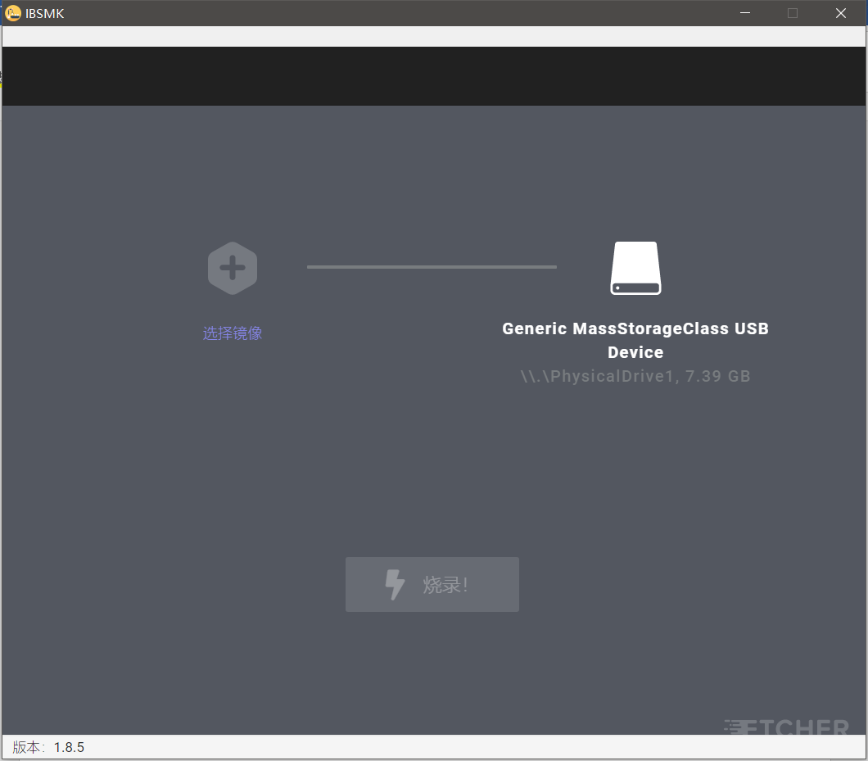
Fig.5
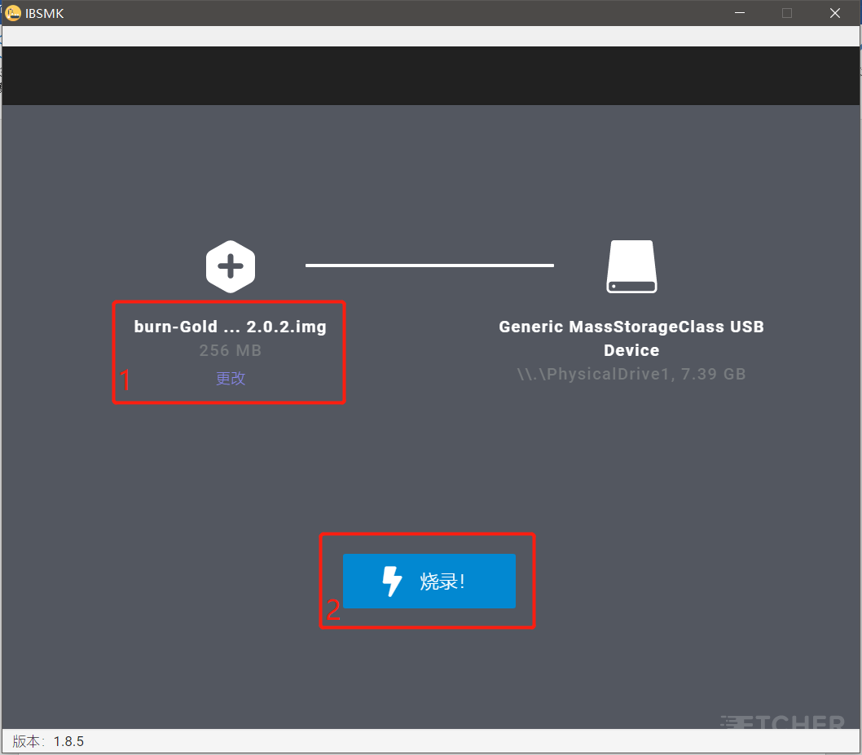
- Click “select file” and upload the firmware, then START. (Shown as Fig.6 and Fig.7) Don’t close the software or pull out the SD card during the burning process. When it reaches 100, the process is completed. And then close the firmware and pull out the SD card.
Fig.6
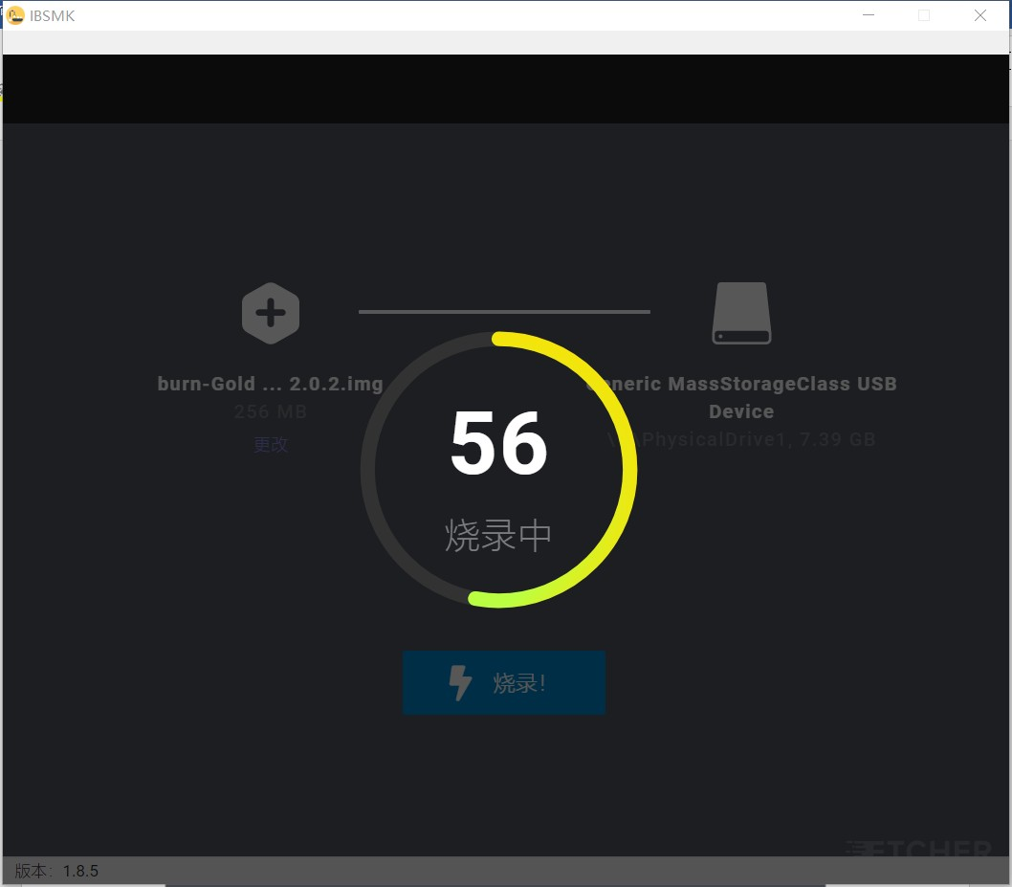
Fig.7

PART 2
Insert the SD card into the miner
- Power off the device but with the net cable on, then insert the SD card into the slot alongside the indicator light. (Fig.8)

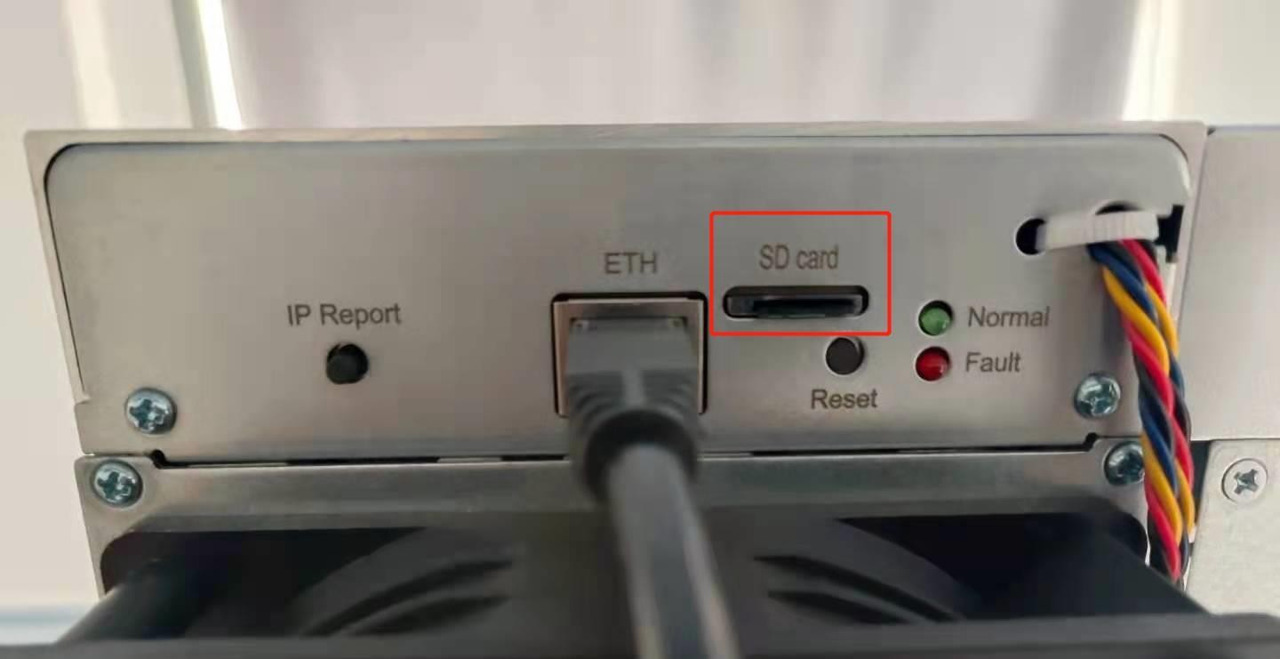
Fig.8

- Power the device on, then you can see the red and green lights flash together, which will last 90 seconds.
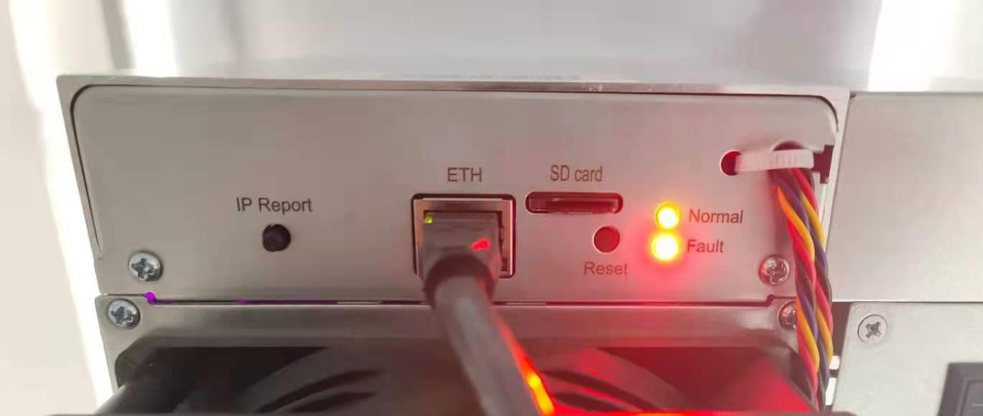
Fig.9

- Wait until only the green light flashes, which means the burning process is basically completed. Then pull out the SD card, the miner will reboot automatically. When the green light is flashing again, it means the miner is in working order. Note: press and pull out the SD card. Make sure the power is on during the process. Otherwise, you need to redo all the procedures.
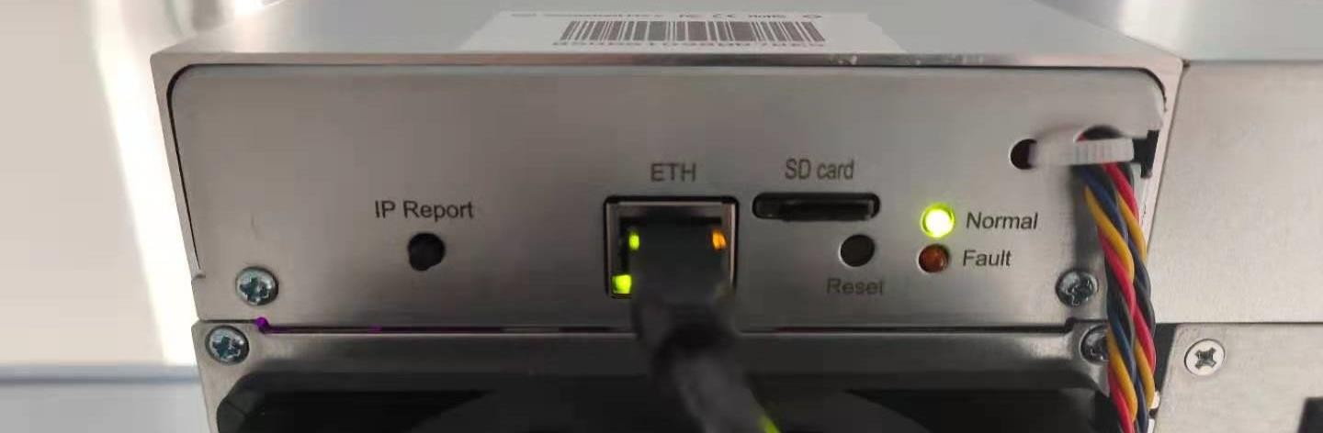
Fig.10

